Vishal Maru

Dr. Bukralia

IT 340 – Assignment #4

April 22, 2018

1.

USE AdventureWorks2012

GO

SELECT CONCAT (ProductID, ' : ', Name) AS IDName

FROM Production.Product;

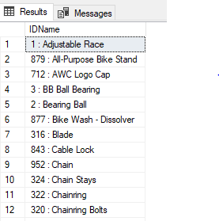

2.

USE AdventureWorks2012

GO

SELECT SalesOrderID, OrderDate, DATEADD(MONTH, 6, OrderDate) AS Plus6Months

FROM Sales.SalesOrderHeader;

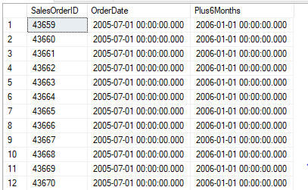

3.

USE AdventureWorks2012

GO

SELECT SalesOrderID, OrderDate,

DATEPART (YEAR, OrderDate) AS OrderYear,

DATEPART (MONTH, OrderDate) AS OrderMonth

FROM Sales.SalesOrderHeader;

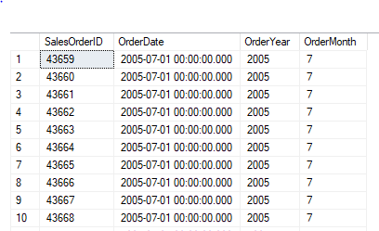

4.

USE AdventureWorks2012

GO

SELECT SalesOrderID, OrderDate

FROM Sales.SalesOrderHeader

ORDER BY DATEPART (MONTH, OrderDate), DATEPART (YEAR, OrderDate);

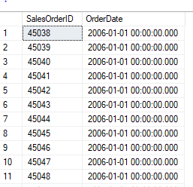

5.

USE AdventureWorks2012

GO

SELECT SalesOrderID, p.ProductID, p.Name

FROM Sales.SalesOrderDetail AS sd

RIGHT OUTER JOIN Production.Product AS p

ON sd.ProductID = p.ProductID;

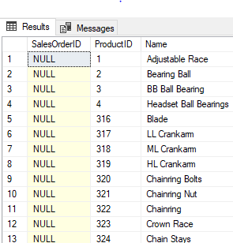

6.

USE AdventureWorks2012

GO

SELECT sh.CurrencyRateID, c.AverageRate, sm.ShipBase, sh.SalesOrderID

FROM Sales.SalesOrderHeader AS sh

LEFT OUTER JOIN Sales.CurrencyRate AS c

ON sh.CurrencyRateID = c.CurrencyRateID

LEFT OUTER JOIN Purchasing.ShipMethod AS sm

ON sh.ShipMethodID = sm.ShipMethodID;

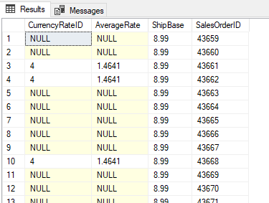

7.

USE AdventureWorks2012

GO

SELECT p.FirstName, p.MiddleName, p.LastName, pr.Name

FROM Person.Person AS p

INNER JOIN Sales.Customer AS c

ON p.BusinessEntityID = c.PersonID

INNER JOIN Sales.SalesOrderHeader AS sh

ON c.CustomerID = sh.CustomerID

INNER JOIN Sales.SalesOrderDetail AS sd

ON sh.SalesOrderID = sd.SalesOrderID

INNER JOIN Production.Product AS pr

ON sd.ProductID = pr.ProductID;

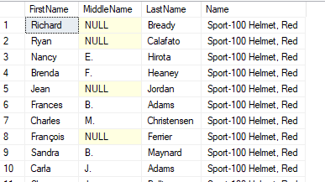

8.

USE AdventureWorks2012

GO

SELECT ProductModelID, COUNT (ProductModelID) AS CountOfProducts

FROM Production.Product

GROUP BY ProductModelID

HAVING COUNT (ProductModelID) = 1;

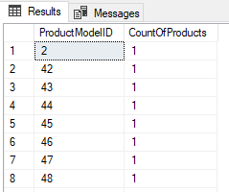

9.

USE AdventureWorks2012

GO

SELECT COUNT (DISTINCT TerritoryID) AS CountOfTerritoryID, CustomerID

FROM Sales.SalesOrderHeader

GROUP BY CustomerID;

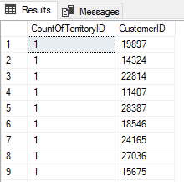

10.

USE AdventureWorks2012

GO

SELECT COUNT(sh.OrderDate) AS CountOfOrders, p.FirstName, p.MiddleName, p.LastName

FROM Sales.SalesOrderHeader AS sh

INNER JOIN Sales.Customer AS c

ON sh.CustomerID = c.CustomerID

INNER JOIN Person.Person AS p

ON c.PersonID = p.BusinessEntityID

GROUP BY p.FirstName, p.MiddleName, p.LastName

ORDER BY p.FirstName;

